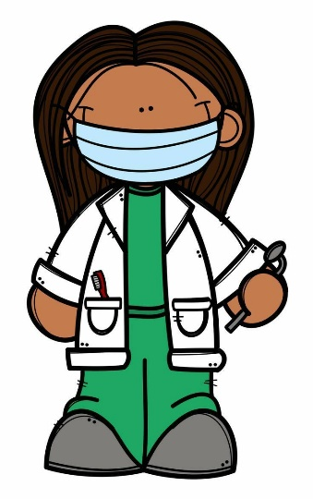

Created : 2024/25

Ratified By Governors: 13/02/25 Review Date: 02/26

**FIRST AID POLICY**

**POLICY STATEMENT**

The Principal and Board of Governors of Carhill Integrated Primaryaccept their responsibility under the Health and Safety (First Aid) Regulations (Northern Ireland) 1982 and Carhill Integrated Primaryacknowledge the importance of providing First Aid for employees, children and visitors within the School.

The staff of recognise their statutory duty to comply with the Reporting of Injuries, Diseases and Dangerous Occurrences Regulations (Northern Ireland) 1997 and agree to abide by the Department of Education and Education Authority procedure for reporting accidents.

Signed_________________________________________________________________

(Principal)

Signed____________________________________________________________________ (Chairperson of Board of Governors)

**1. INTRODUCTION**

1.1‘First Aid is the initial assistance or treatment given to someone who is injured or suddenly taken ill. Staff administering First Aid should seek to assess the situation, protect themselves and the casualty from further danger, deal with any life-threatening condition and where necessary obtain medical assistance or refer the casualty to hospital as quickly as possible. In developing this policy, the school followed guidance materials from Department of Education and Education Authority.

**2. STATEMENT OF FIRST AID PROVISION**

2.1 The School’s arrangements for providing First Aid will: -

* Place a duty on the Principal and Board of Governors to approve, implement and review the First Aid policy;
* Place individual duties on all employees;
* Report and record accidents using relevant form to the EA Northern Region;
* Record all occasions when First Aid is administered to employees, pupils and visitors.
* Provide equipment and materials to provide First Aid treatment;
* Make arrangements with Education Authority Northern Region to provide First Aid training to employees, maintain records of training and review annually;
* Establish a procedure for managing accidents in school which require First Aid treatment;
* Provide information to employees on the arrangements for First Aid;
* Undertake a risk assessment of the First Aid requirements of the School and review on a regular basis;
* Use the information from the risk assessment of First Aid to determine the number and level of trained staff and also any additional requirements (eg specialised training for children with particular medical needs);
* Notify parent/guardian that first aid treatment was given to the child.

**3. ARRANGEMENTS FOR FIRST AID**

3.1 The School will provide materials and equipment and facilities to provide First Aid. The location of the First Aid Kits in the School are: -

***Mobile***

*Entrance Hall*

***Main school***

*Staff Toilet*

The contents of the kits will be checked on a regular basis by Mrs Tanya Collins, Mrs Magee and Mrs Russell, the principal.

**The School First Aiders are:**

Mrs Tanya Collins

Mrs Nicola Magee

Before undertaking any off-site activities, the level of first aid provision will be assessed by the principal and at least one First Aid Kit will be taken along. This is part of our regular Risk Assessment arrangements.

**4. INFORMATION ON FIRST AID ARRANGEMENTS**

4.1 The Principal will inform all employees at the school of the following: -

* The arrangements for recording and reporting of accidents;
* The arrangements for First Aid;
* Those employees who are qualified First Aiders;
* The location of the First Aid Kits.

In addition, the Principal will ensure that photos of first aiders and related material are displayed throughout the School providing the following information: -

* The names of employees with First Aid qualifications;
* Duty rota in agreed areas
* Location of the First Aid Box.

All members of staff will be made aware of the School’s First Aid policy. No member of staff should attempt to give First Aid unless they have been trained.

**5. RECORDING CHILDREN WITH MEDICAL ISSUES**

5.1 The school will ensure that children with medical issues are recorded centrally.

Parents will be asked to provide evidence to confirm medical issues – from GP/Consultant.

5.2 A list of will be compiled and be displayed in classrooms/lunch area and staffroom to ensure members of staff are aware of children with medical needs.

5.3 First Aid training for specific children will be organised through Education Authority.

**6. ACCIDENTS INVOLVING BUMPS TO A PUPIL’S HEAD**

6.1 The consequence of an injury from an accident involving a bump or blow to a pupil’s head is not always evident immediately and the effects may only become noticeable after a period of time.

6.2 Where emergency treatment is not required a ‘Head Bump’ notification will be sent home/and or a phone call to the parent/guardian.

**7. TRANSPORT TO HOSPITAL OR HOME**

7.1 The Principal will determine the appropriate action to be taken in each case. Where the injury requires urgent medical attention, an ambulance will be called and the pupil’s parent or guardian will be notified. If hospital treatment is required, then the pupil’s parent/guardian will be called for them to take over responsibility. If no contact can be made with parent/guardian or other designated emergency contacts, then the Principal may decide to transport the pupil to the hospital.

7.2 Where the Principal makes arrangements for transporting a child then the following points will be adhered to:-

* Only staff cars insured to cover such transportation will be used;
* No individual member of staff will be alone with the pupil in a vehicle;
  + A second member of staff will be present to provide supervision of the injured pupil.